Group Members
Abreu, Xyrill John F.
Balatayo, Brielle Edrian A.
Gonzales, Michael Rhoi L.
Ibarra, Kenneth Gene

Subject
ITEC 116 – System Integration and Architecture

Title of Activity
Notes API + UI

Short Description
This is a personal notes app with login and registration features. It allows users to create, read, update, and delete their own private notes.

System Overview
The personal notes app consists of a React.js frontend and a Nest.js backend with MySQL database. Users can register, login, and manage their personal notes in a secure environment. The system uses JWT (JSON Web Token) for authentication and provides a clean, intuitive interface for note management.

Features
- User Registration and Authentication
- Create Notes
- Read Notes
- Update Notes
- Delete Notes
- Secure JWT-based Authentication
- Responsive UI Design

Technologies Used
Objective | Objective
Frontend | React.js
Backend | Node.js, Nest.js, TypeScript
Database | MySQL
Styling | CSS
Tools | VS Code, XAMPP, GitHub

Installation and Setup

Step 1 – Clone Repository
git clone https://github.com/skyana-08/ITEC116

Step 2 – Backend Setup
cd backend
npm install
npm start / npm run start:dev

Step 3 Frontend Setup
cd frontend
npm install
npm start / npm run dev

Step 4 – Database Setup
Import the Database file in your database.

Output Screenshots
Sign up Page
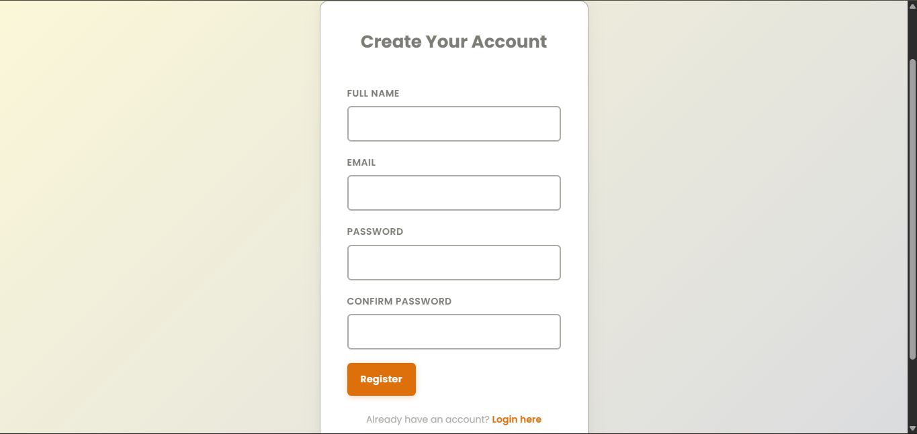
Sign up Page: Register the user.
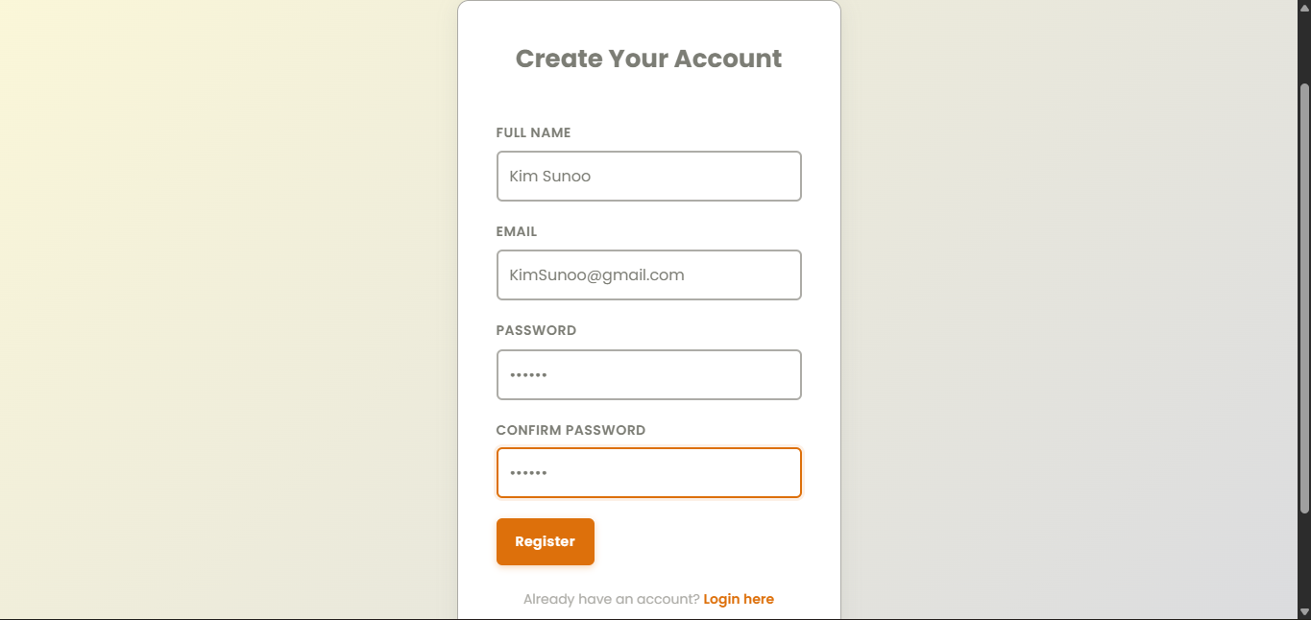

Login Page
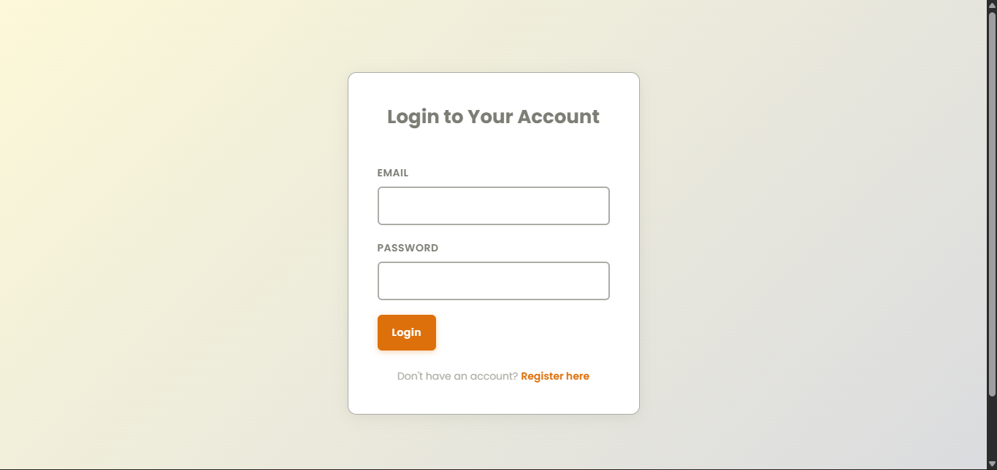

Login Page: Log in the user.
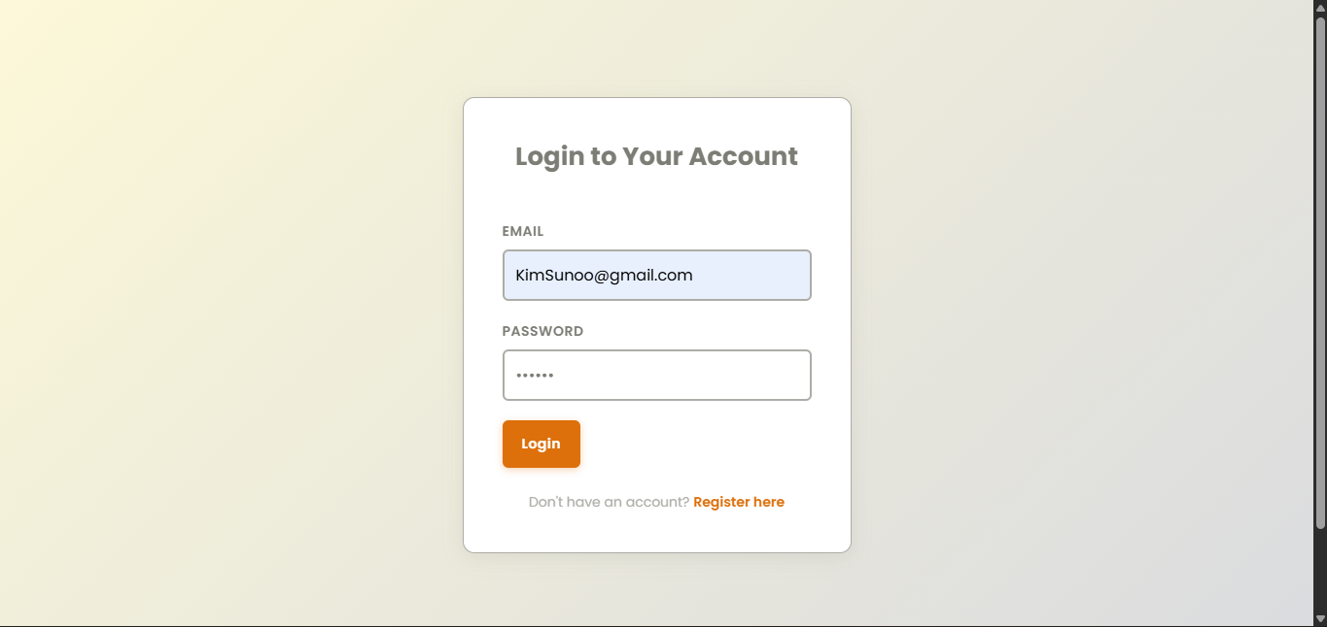

Dashboard Page
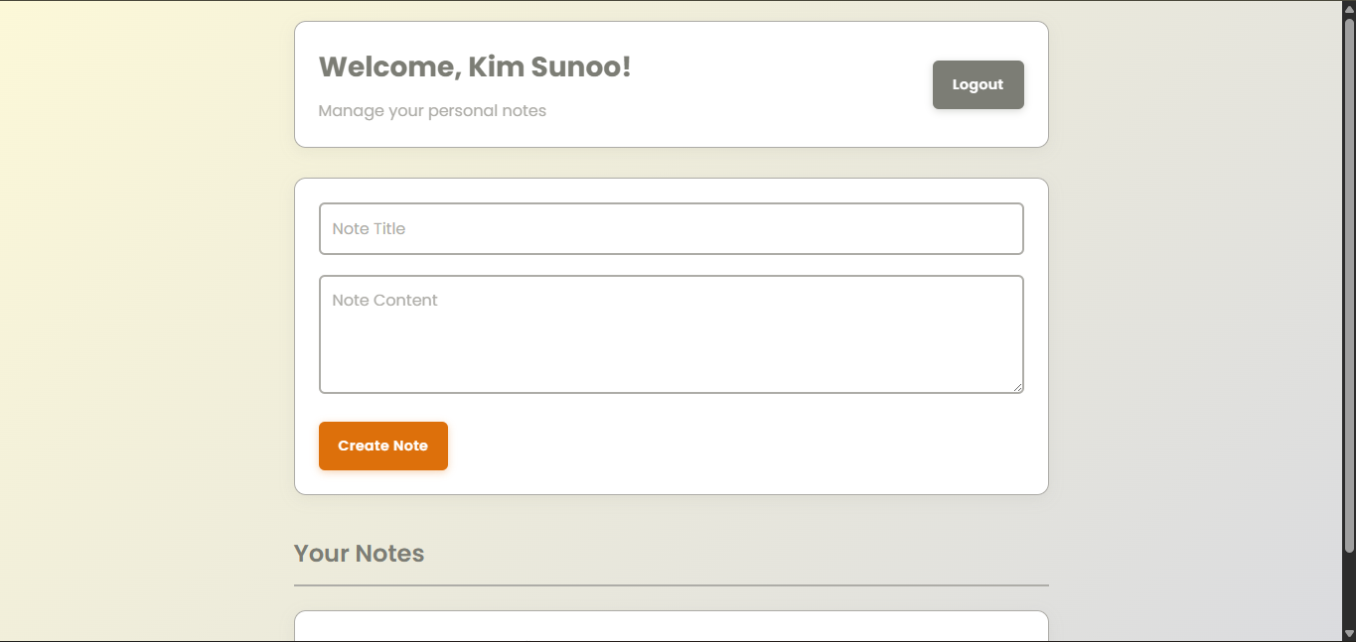

Dashboard Page: Creating Note.
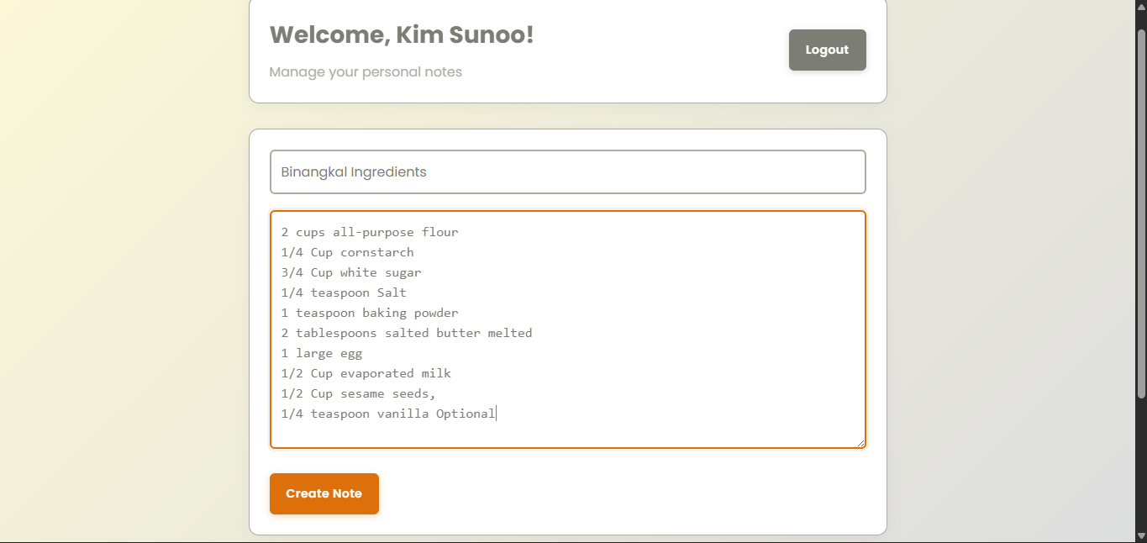

Dashboard Page: Note Created.
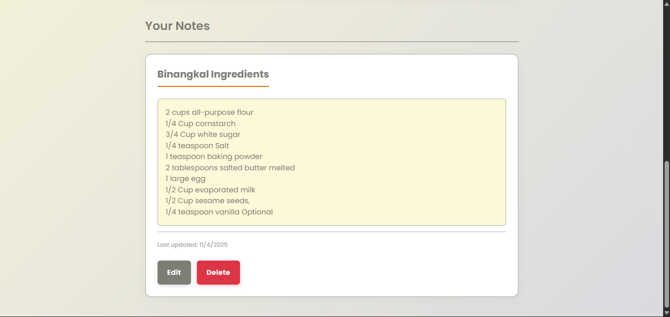

Dashboard Page: Editing Note.
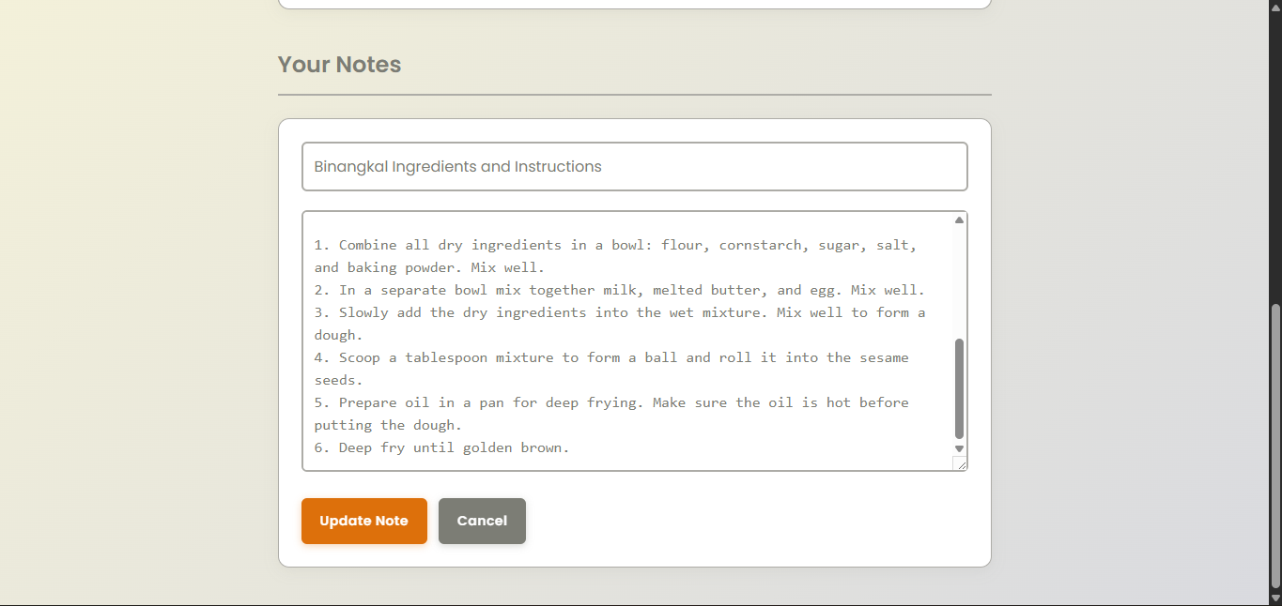

Dashboard Page: Note Updated.
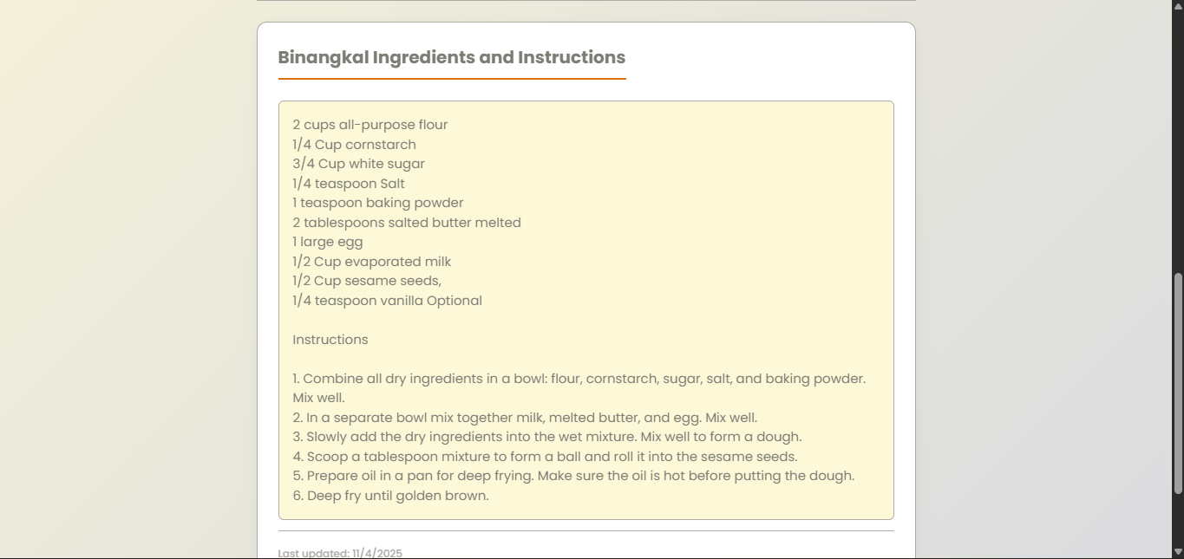

Dashboard Page: Deleting Note.
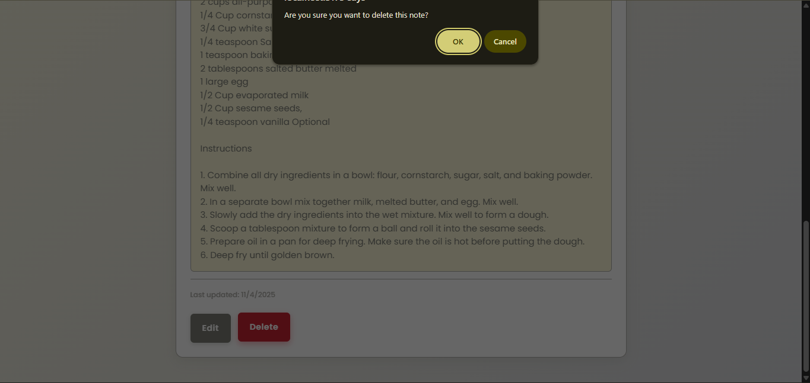

Dashboard Page: Note Deleted.
